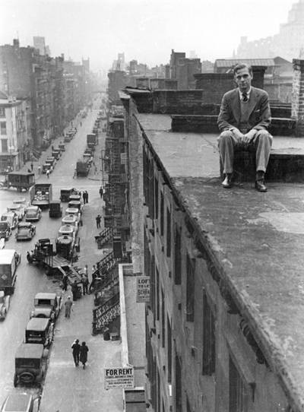[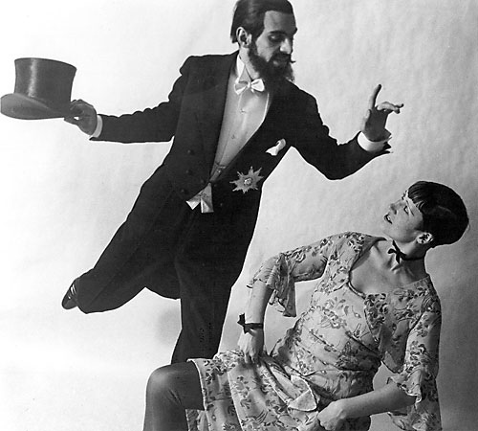](http://www.flickr.com/photos/kraftgenie/4978777655/in/photostream/)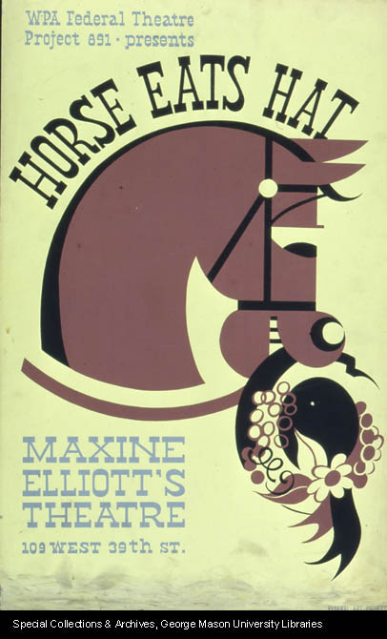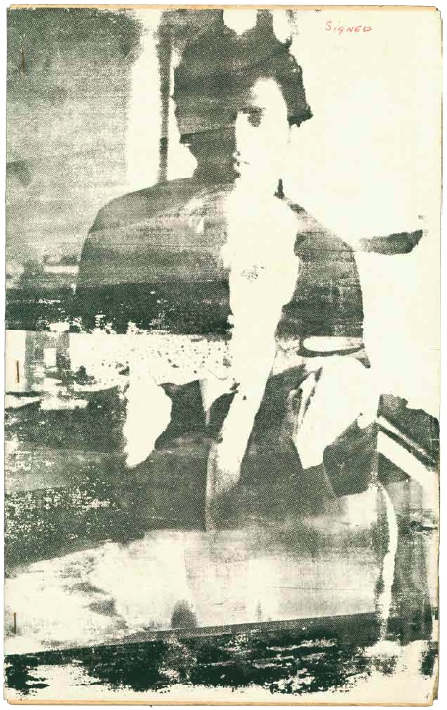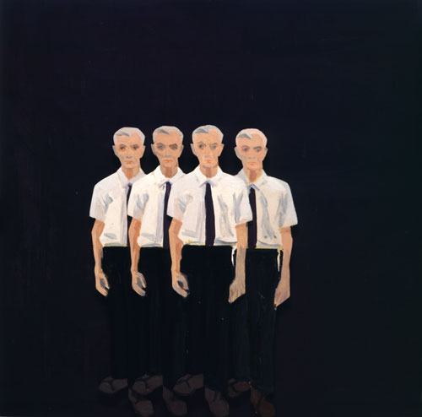

**Fig 1:**

Edwin Denby in New York, Photograph by Rudy Burckhardt. Estate of Rudy Burckhardt.

RIGHTS: Andrew Arnot at Tibor Nagy Gallery (New York) has provisionally granted me rights to reproduce this photo in the essay. Follow up with arsny.com for documentation.

**Fig 2.**

Edwin Denby and Claire Eckstein in Regimentstochter (Gaetano Donizetti), Theater am Schiffbauerdamm, Berlin 1930. Photo by Ellen Auerbach for ringl+pit.

URL: http://www.flickr.com/photos/kraftgenie/4978777655/in/photostream/.

For rights, contact the *Akademie der Künste Berlin*.

**Fig. 3.**

Edwin Denby, Orson Welles, *Horse Eats Hat* (1936)

Rights: George Mason University Libraries, Special Collections & Archives [Unlikely to pose any problems for rights]

URL: <http://hdl.handle.net/1920/3871>

**Fig. 4.**

Edwin Denby (seated) and Gerard Malanga. Image by Andy Warhol

*"C": A Journal of Poetry*, 1.4 (1963). ed. Ted Berrigan

URL: high resolution TIF file in my possession, scanned by Northwestern Special Collections. RIGHTS: ?? The image is the cover of a mimeograph magazine.

**Fig. 5**

Alex Katz, American, b. 1927, *Edwin Denby*, 1964, oil on masonite, Gift of Walter K. Gutman, Class of 1924, 1966.30 (Bowdoin College Museum of Art) RIGHTS: Contact artist's son, poet/curator Vincent Katz (vincentkatz@mac.com). I know Vincent and can reach out as necessary.